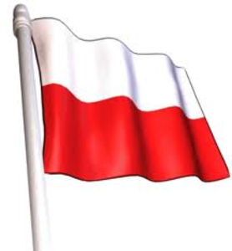
Tychy, Poland May 18th-22nd
Itinerary

Day One - Monday 18th May
Arrive at school at 3.45 a.m.
Please ensure that you arrive at school promptly to allow time for toilets and loading of luggage.
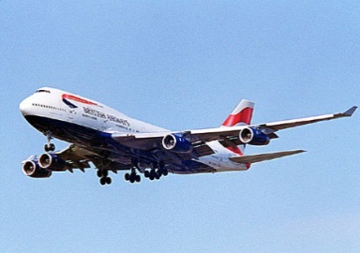
Mr Holditch will be driving the minibus to the airport but an additional people carrier has also been booked to ensure sufficient room for luggage.
Having arrived at Heathrow we will make our way to the BA baggage drop to check in our luggage and then proceed straight to passport control. Please ensure that luggage guidelines have been adhered to, including liquids in hand luggage.
Luggage labels will be handed out prior to the 18th May and should be attached to the children’s luggage.
Once we are through to the departure lounge we will purchase breakfast for the children as well as bottles of water for the flight (the children will not have to pay for this). Please ensure that the children have a packed lunch which can be eaten on the flight.
The flight is due to arrive at Krakow at 12.10 p.m. We will be picked up from the airport by mini bus and taken directly to the hotel. Transfer time is approximately 1 hour.
After checking into our rooms we will be taken to our host school (Szkola Podstawowa nr 18) by taxi. Please note that the children will always be travelling with a member of the Godinton Staff.
A cultural evening has been organised by the host school for the children between 5.00 p.m. and 7.00 p.m. The children will be involved in activities with children from the schools in Poland and Belgium which will allow them to find out more about Belgian, Polish and British culture. Food has been organised by the Polish school.

We will then return to the hotel.
Key things to remember:
- Ensure that luggage has been packed appropriately
- Arrive at school promptly for a swift departure
- You may want to bring a small amount of English money for the airport
- A packed lunch for the flight

Day Two – Tuesday 19th May
We will be getting up at approximately 7.15 a.m. and having breakfast together as a group in the hotel.
We will then either walk or take a taxi to our host school.
The morning will be spent working on activities connected with the theme ‘No More War.’ These workshops will be led by staff from the host school and will involve Polish, English and Belgian children working together. Godinton Staff will accompany our children. Before lunch, the children will present some of the work they have produced.
The children will have a hot lunch at our host school at approximately 1.00 p.m.
2.30 p.m. – 4.00 p.m. We will take a sightseeing tour of the town with children from the host school and those visiting from Belgium. This will include the town museum. Polish spending money will be handed out to any children who have requested it.
We have been invited to spend the evening with the families of children who attend our host school. The children will go in groups of 2 or 3 with a member of the Godinton Staff and will be picked up and taken back to the hotel by our hosts. We will have a meal in their home and return to the hotel at 7.30 p.m. I have arranged gifts for us to take to give our hosts.
We will spend the rest of the evening at the hotel.

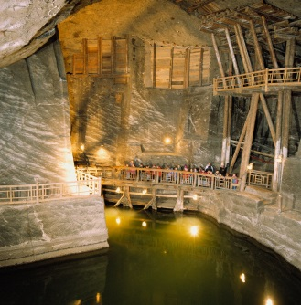
Day Three – Wednesday 20th May
We will be getting up at approximately 7.15 a.m. and having breakfast together as a group in the hotel.
We will then either walk or take a taxi to our host school. We will spend an hour and a half working at our host school on an art / history based activity.
We will have an early lunch at the school before heading off on our afternoon excursion to the Wieliczka Salt Mine. We will be joined by children from the schools in Poland and Belgium and will have an English tour guide. The journey will be made by coach and takes approximately 2 hours.
It can be cool down in the mine and the children will need comfortable footwear.
The salt mine is a major attraction in the area. We will be finding out more about this before we depart but you may wish to have a look at their website:
http://www.wieliczka-saltmine.com/
Dinner will be eaten at the salt mine and we aim to arrive back at the hotel by 9.00 p.m.

Day Four – Thursday 21st May
We will be getting up at approximately 7.15 a.m. and having breakfast together at the hotel.
We will then be collected from the hotel by coach for a visit to the Museum of the Silesian Uprisings. This is a modern, interactive museum which explores the history of the region. It has descriptions in English.

We will be having lunch in a restaurant close to the museum in the afternoon.
We then return to our host school for fun activities in the afternoon and a picnic tea.
We will spend the evening in the hotel.

Day Five – Friday 22nd May
We will be getting up at approximately 7.00 a.m. and having breakfast together at the hotel.
We will then make our way to our host school and will spend the morning leading a presentation of what the theme ‘No More War’ means to us. The children will have prepared some things to take in school over the next few weeks. This will be presented to children and parents from our host school as well as local dignitaries.
Our transfer will collect us from our hotel at 12.00 p.m. and take us to the airport in Krakow. We will have lunch (sandwich) at the airport once we are through to the departure lounge.
A further snack will be provided during the flight and again we will purchase drinks for the children.
Our flight leaves Krakow and is due to return to Heathrow at 5.30 p.m. Mr Holditch will be bringing the mini bus to collect us and again, further transportation has been booked to ensure that we have plenty of room for luggage.
We will make a stop at the services on the way home and the children will have a McDonalds / Burger King tea.
We aim to return to school at 8.30 p.m. but will text parents once we have arrived back in the UK with regard to more precise timings.

